**ECSE 597 Report**

**Q1**

Figure 1 - Backward Euler

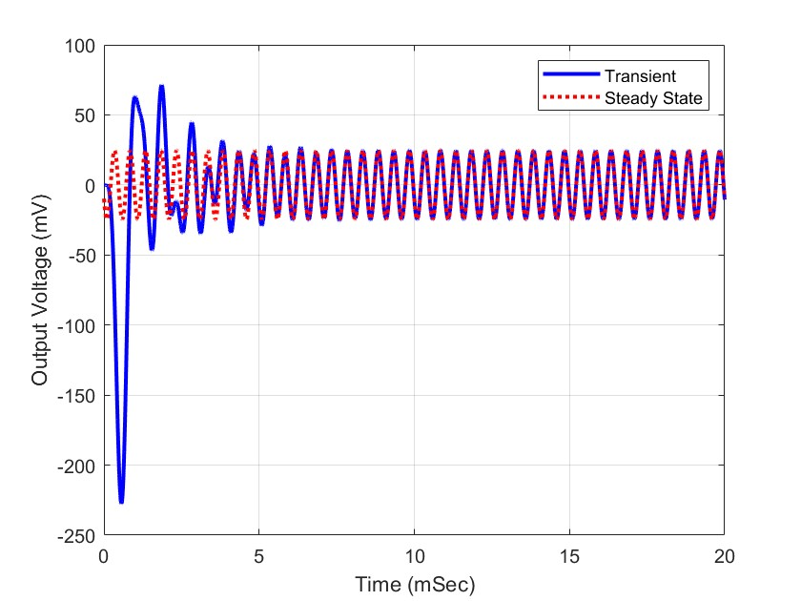

Figure 2 - BE Simulation

As shown in Figure 2, the transient response gradually converges to the steady state response, which is as expected.

**Q2**

Figure 3 - Trapezoidal Rule

Figure 4 - TR Simulation

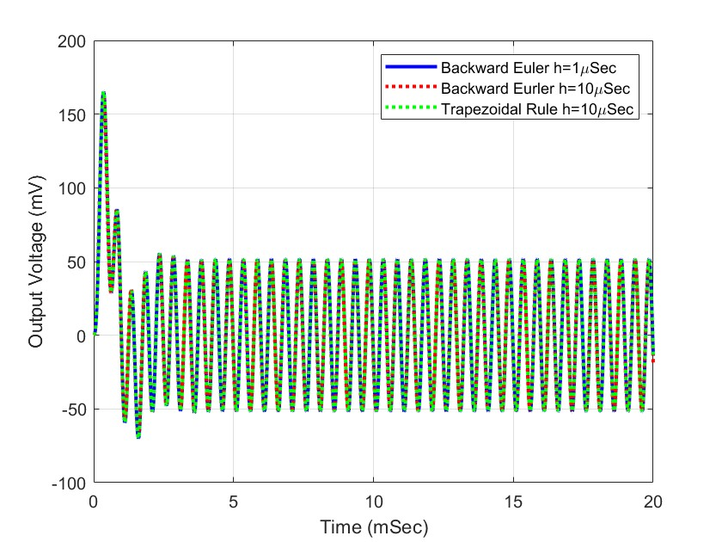

As shown in Figure 4, it can be deduced that both BE and TR methods can generates the same results and are both stable in most cases.

**Q3**

Figure 5 - Pole Calculation

Figure 6 - Forward Euler

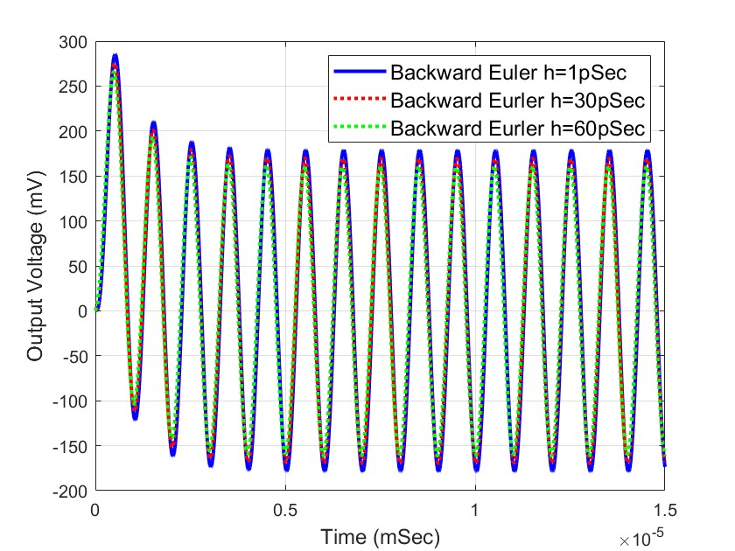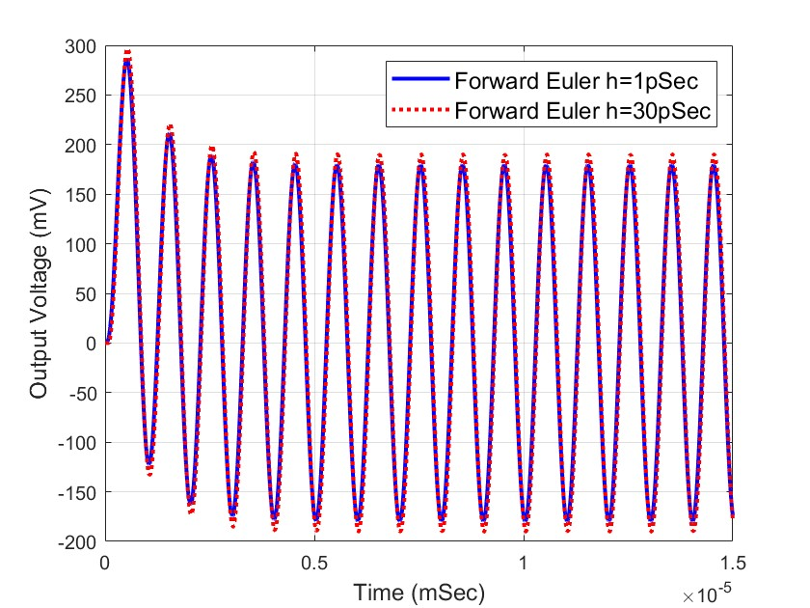

Figure 7 - FE Simulation (60 ps)

Figure 8 - FE Simulation (1 ps & 30 ps)

Figure 9 - Pole Values

Figure 10 - BE Simulation Q3

As shown in Figure 7 and 9, FE method is stable when step size h is 1 ps and 30 ps, and the results are the same as the BE method.

According to the property of FE method mentioned in class, the value of poles and the step size need to satisfy the condition of to have a stable simulation. By examine the poles with the eigen value function as shown in Figure 6, where the values are shown in Figure 8, the step size needs to be considered for the most negative pole of . In this case, the step size needs to be smaller than 56.624 ps to have a stable simulation for FE. This is verified in Figure 10, where the simulation diverges when the step size is 60 ps.

**Q4**

Figure 11 - Perturbation Method (Part A)

Figure 12 - Perturbation (Part B)

**Q5**

Figure 13 - Differentiation Method (Part A)

Figure 14 - Differentiation Method (Part B)

**Q6**

Figure 15 - Adjoint Method (Part A)

Figure 16 - Adjoint Method (Part B)

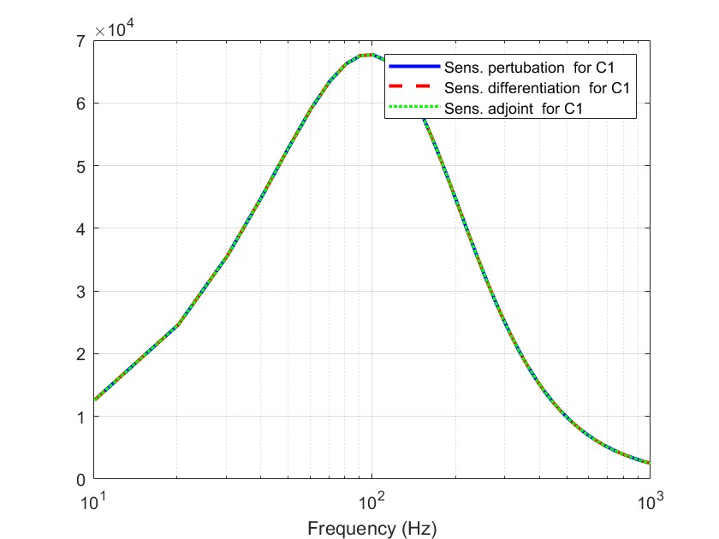**Q7**

Figure 17 - C1 Absolute

Figure 18 - R1 Absolute

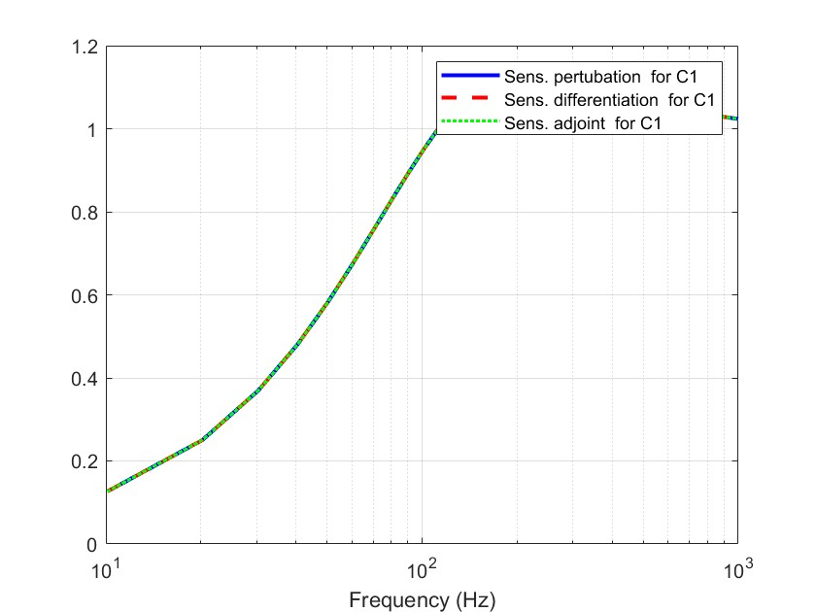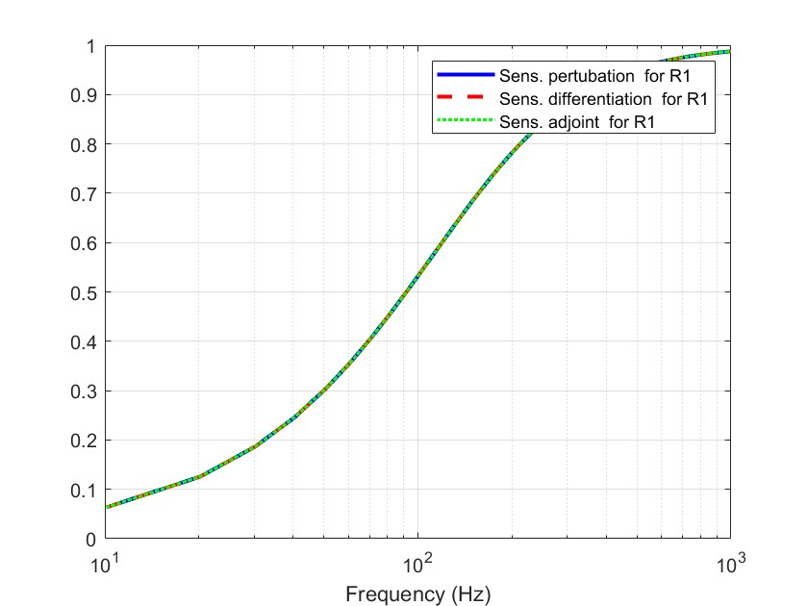

Figure 19 - C1 Relative

Figure 20 - R1 Relative